**Game Introduction**

**Game: Adventurer**

Screenshots

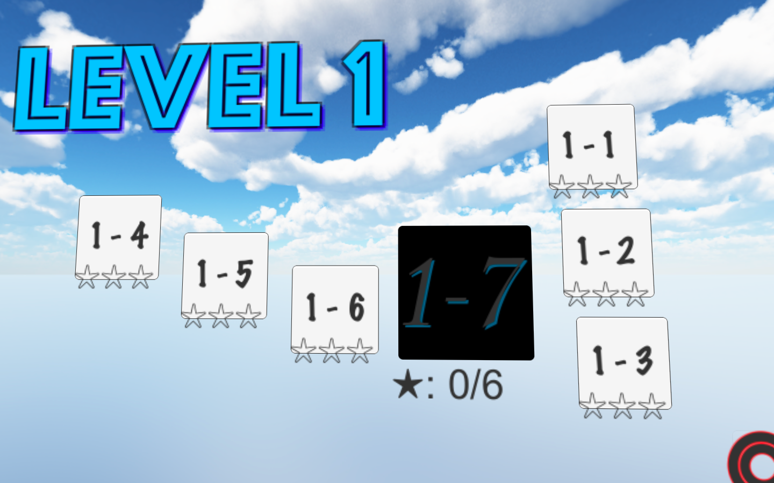

Main menu of level 1

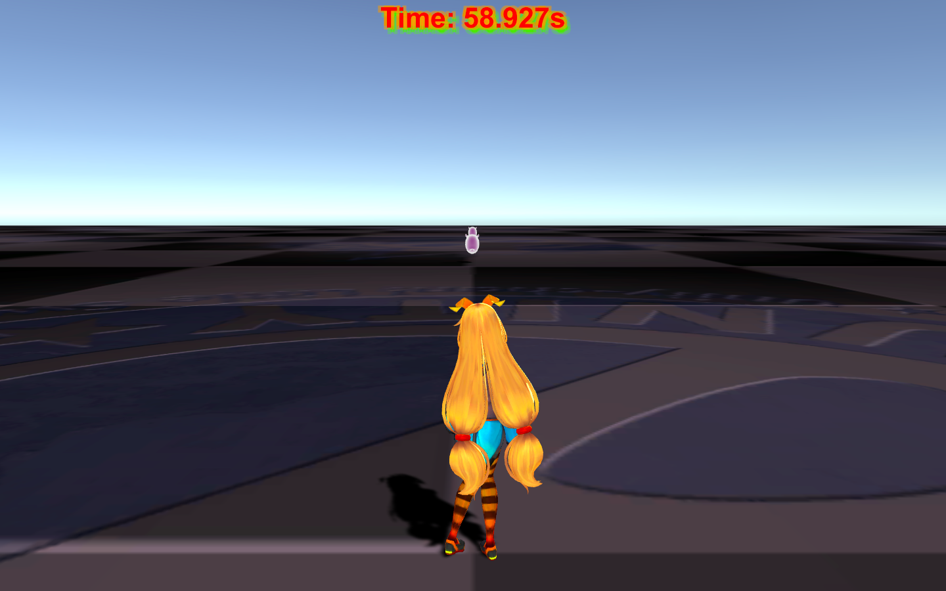

Level 1-1. Run to escape the chase of enemies!

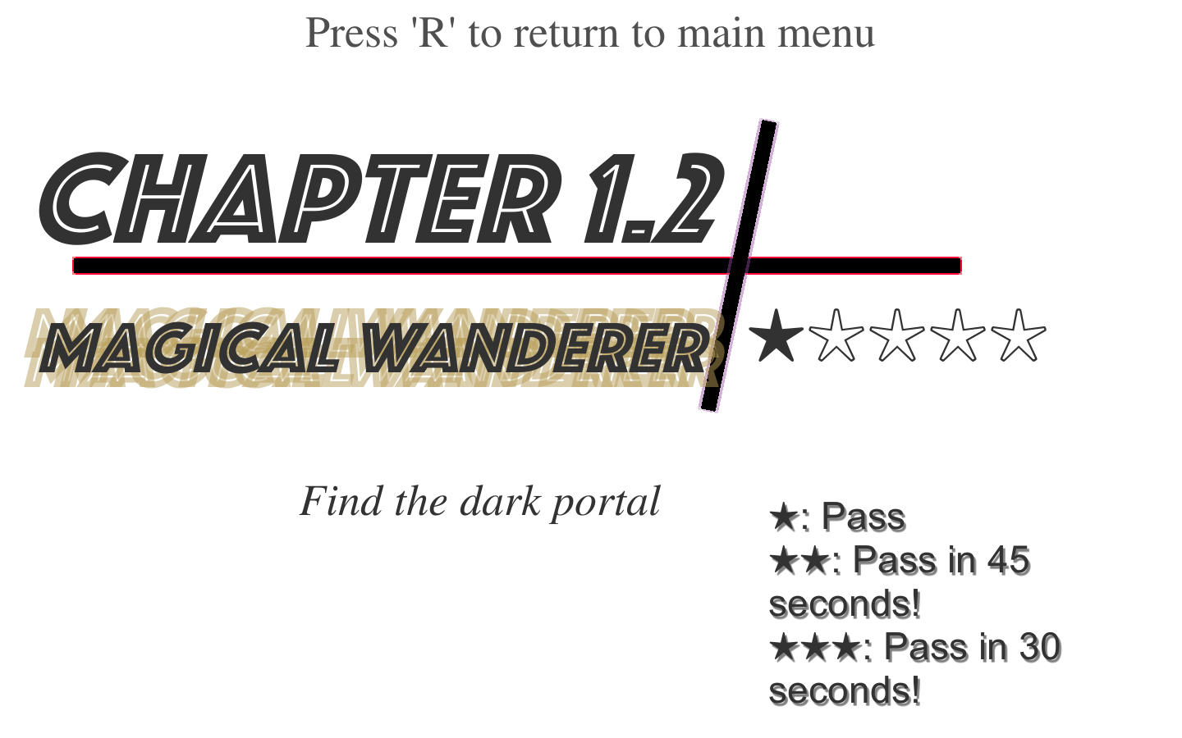

Level 1-2 Preload. Hints and passing conditions are mentioned here.

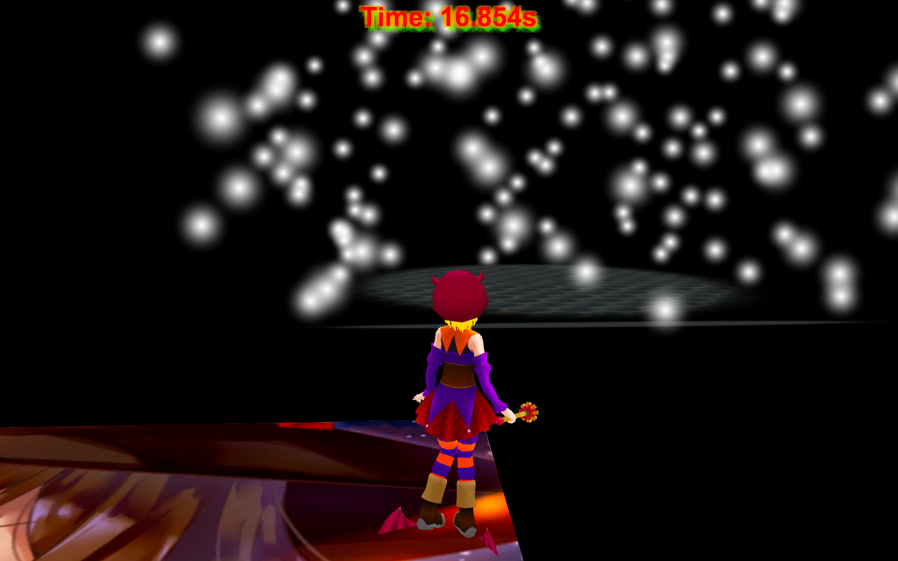

Level 1-2. There are many platforms and player need to do parkour to get to destination.

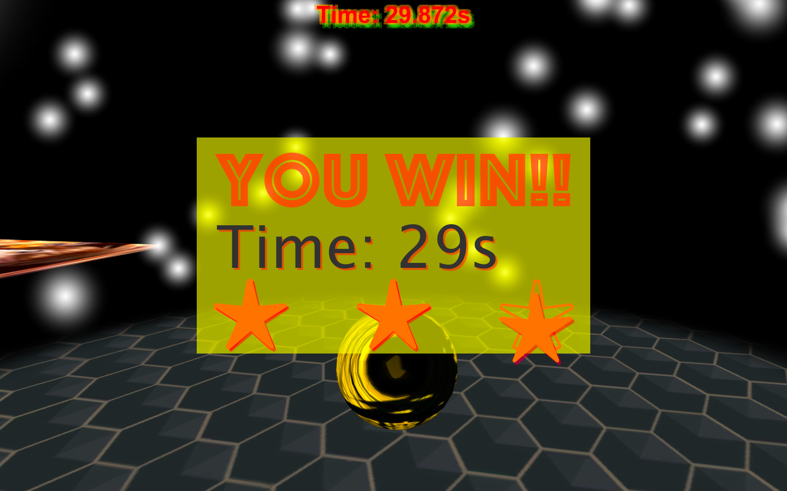

When you win, the winning block will appear.

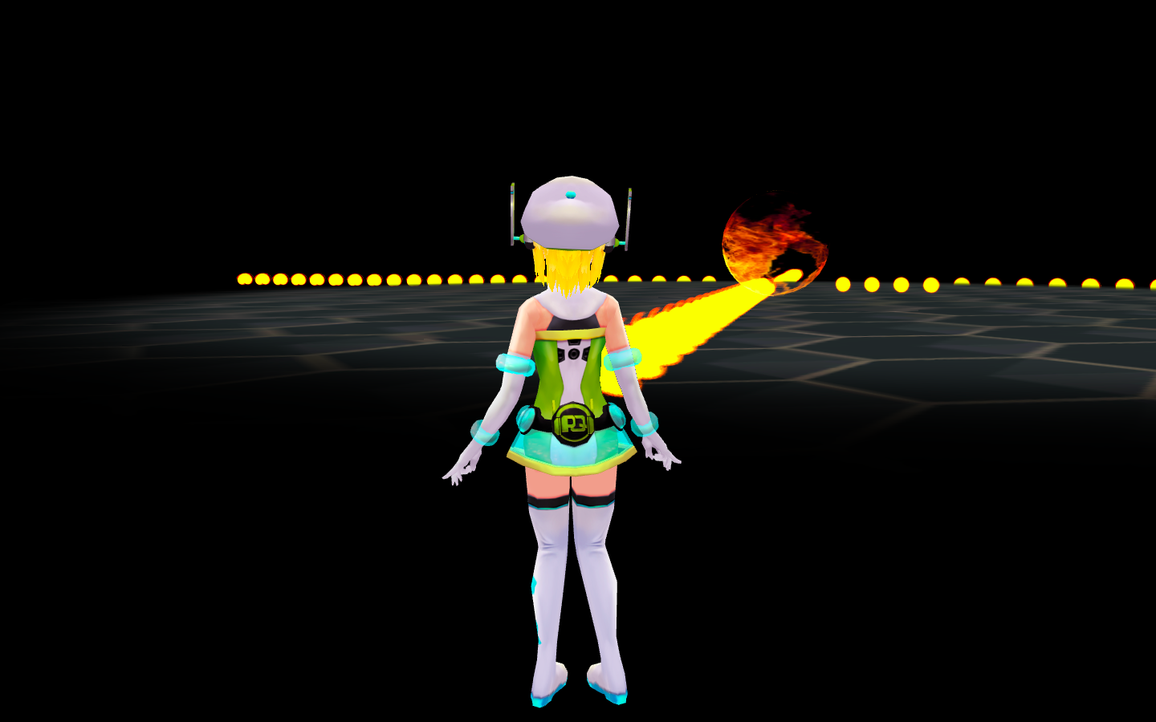

Level 1-3. To win, player has to understand the hints given at the preload. Both skills and puzzle solving are needed. Sometimes death is not a bad option!

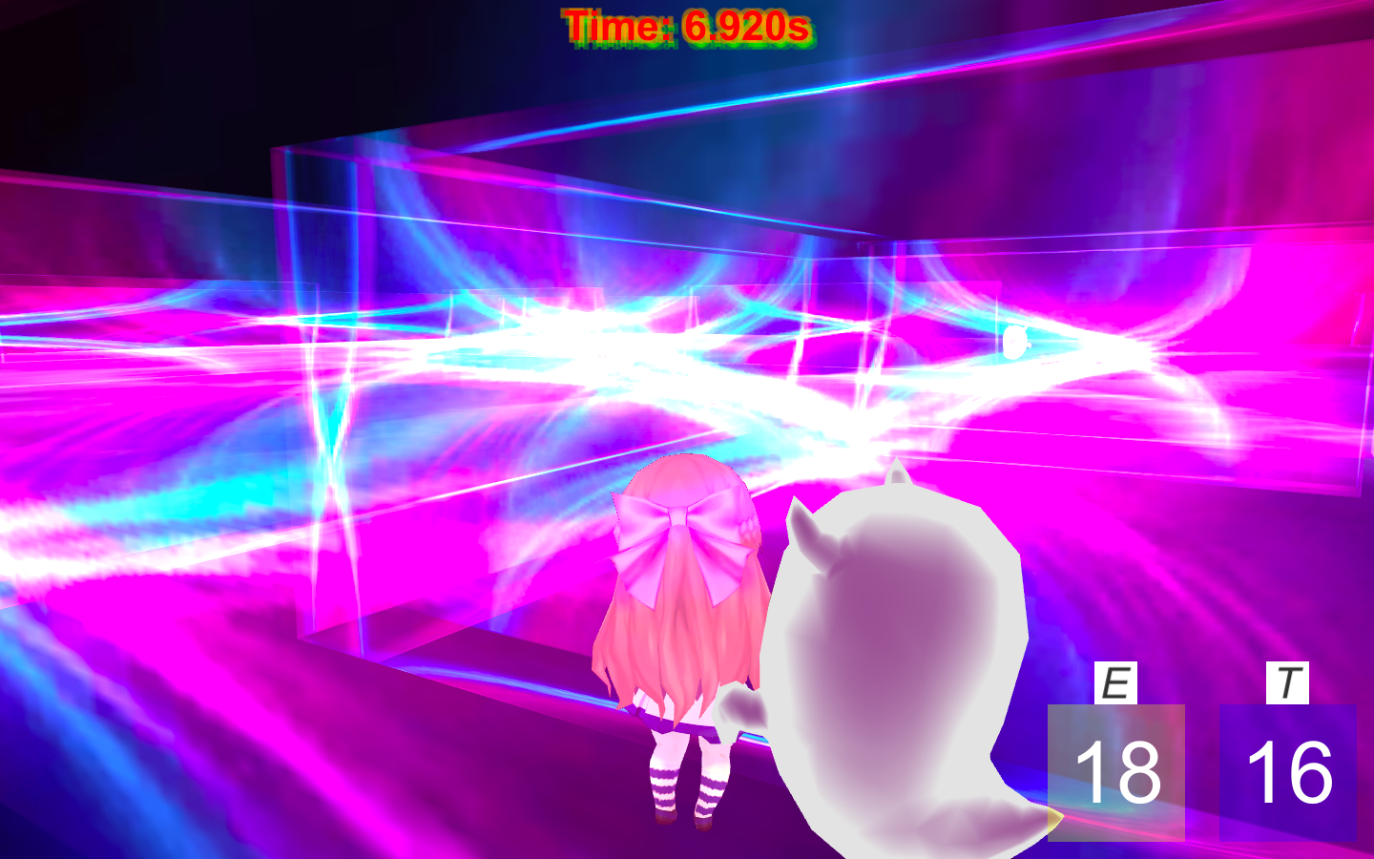

Level 1-4. Player needs to use abilities to run away from enemies and defeat them. Player has to get accustomed to the map in order to pass as quickly as possible to get 3 stars.

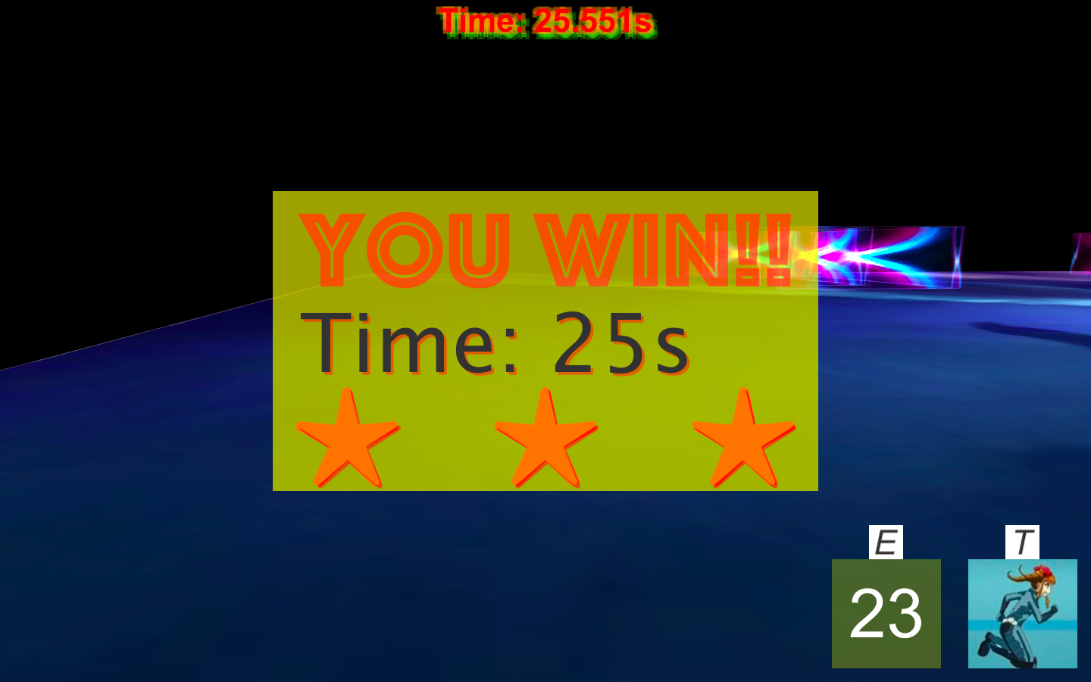

Level 1-4. Victory!

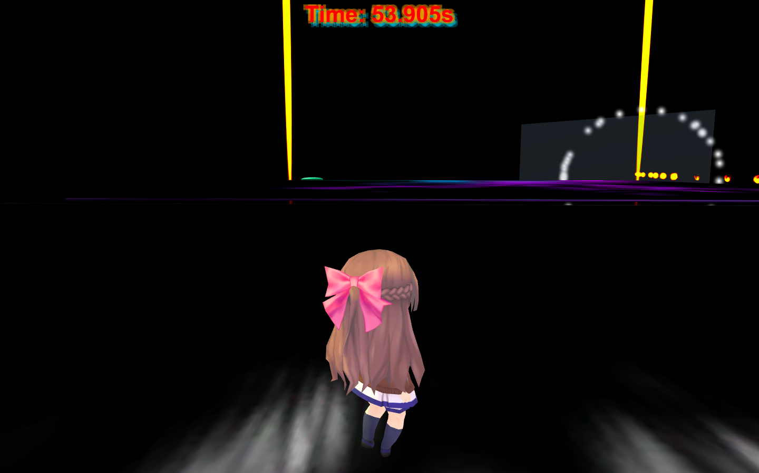

Level 1-5. Player needs to avoid traps and figure out a way to disable the cannon. The rotating camera increases the difficulty, so skill is also important.

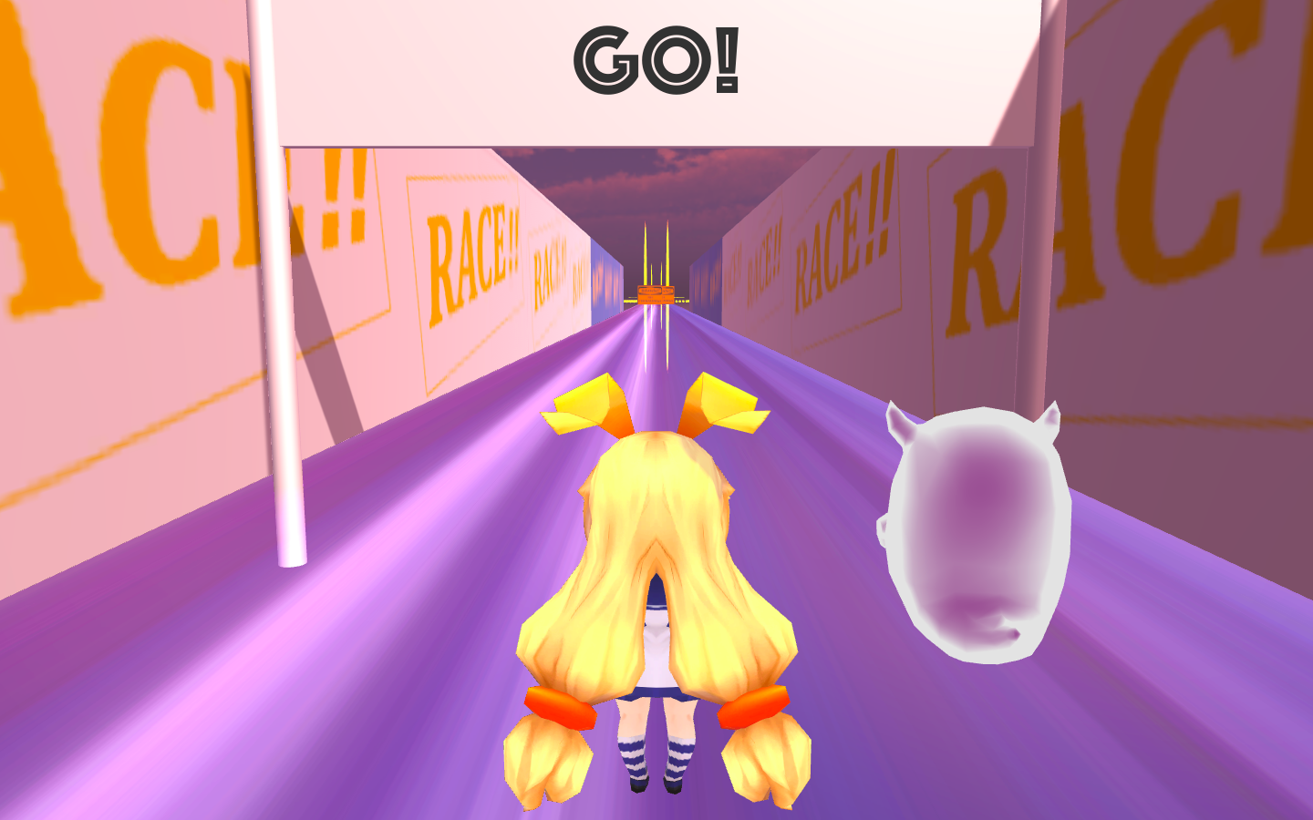

Level 1-6. Race with the enemy! Collect stars and avoid barricades in the run.

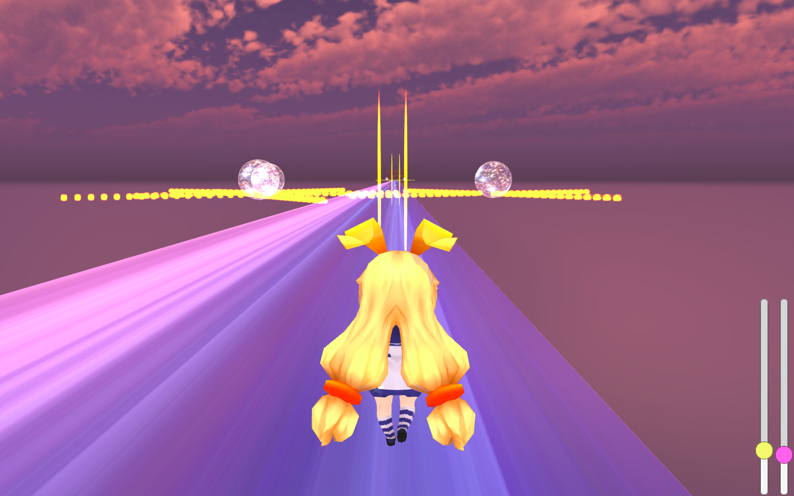

Level 1-6. There are several stages through the run. Player has to jump over the fire, avoid bullets, and the most important, run faster than the enemy!

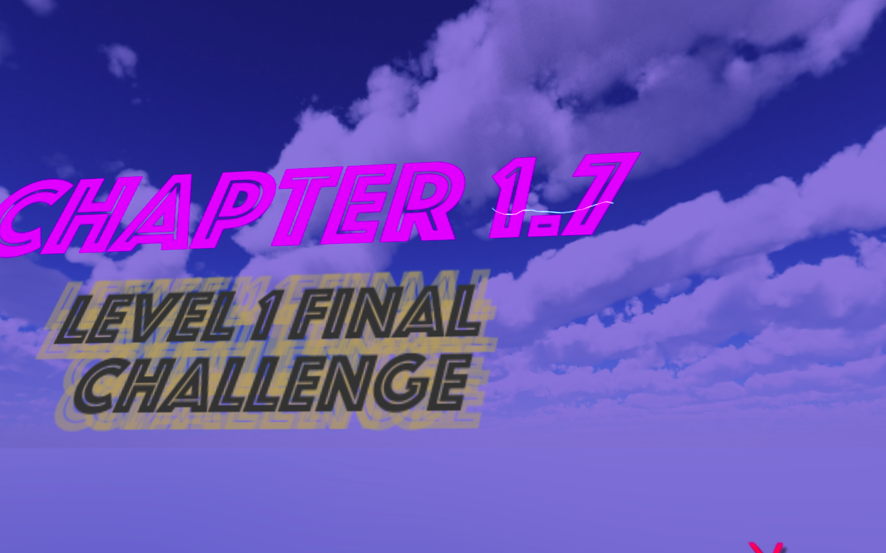

Level 1-7, the final challenge. This level is still under development. More levels are coming, and a story that connects different chapters will be shown.

This is an adventure game with different levels that requires players to find a way to pass each level by solving a “puzzle”.

To play the game, the player needs W/A/S/D to move around, space to jump and several other keys for abilities. Each level has a particular goal.

There are various elements combined in this game: the player has to do some parkour in order to reach the final destination, use abilities and skills to escape the chase of enemies, go pass traps and find victory triggers through hints from words.

The hardest part is designing each level. I carefully designed each level of the game so that it will not be too hard or too easy. Both skills and puzzle solving are needed, and after several trials and errors, the player could find the correct path to victory.

In the future, I plan to develop more levels and establish a story throughout each level: the story of heroine traveling through the universe. Also, more scientific puzzles will be designed.

**Game: College Life of a Programmer**

Screenshots

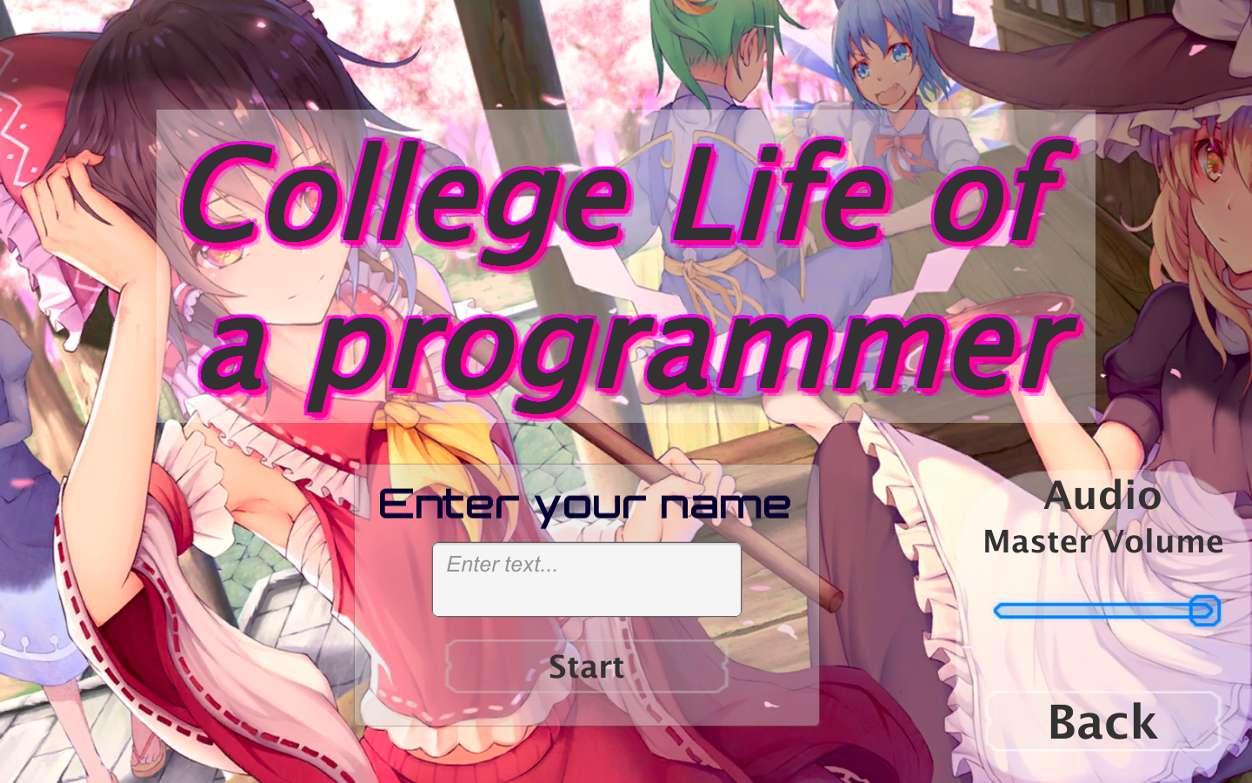

The starting scene. Player can choose a name for the character.

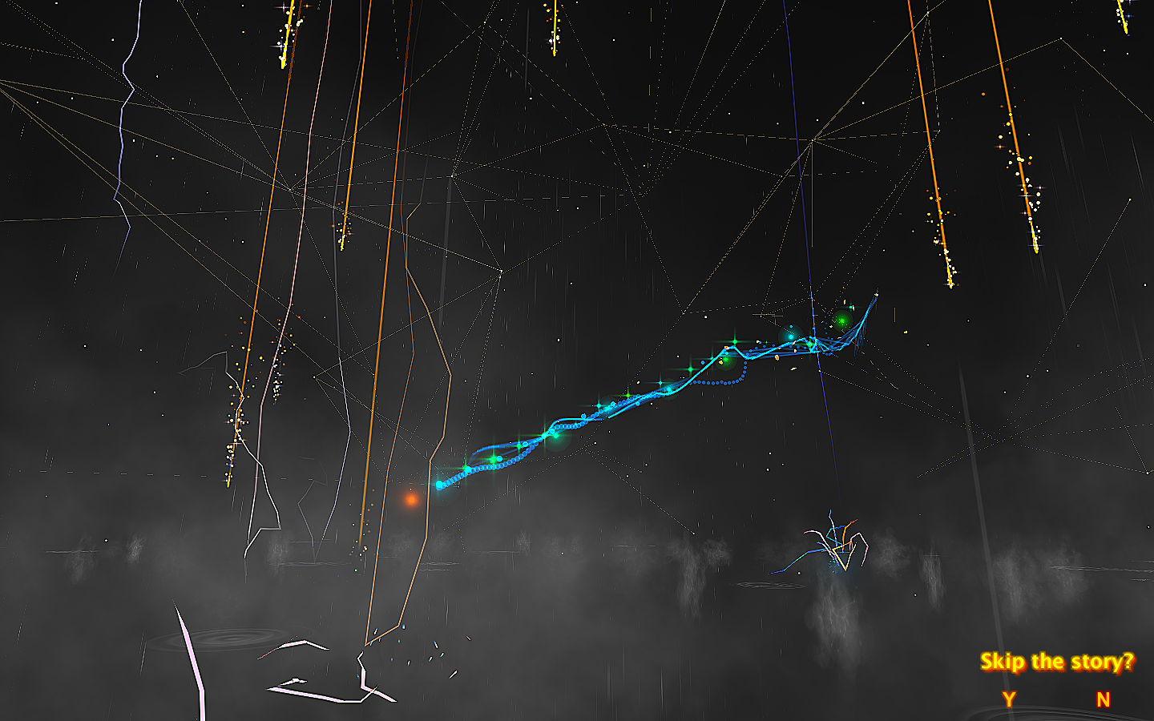

Player can choose to skip the story when they try for a second time.

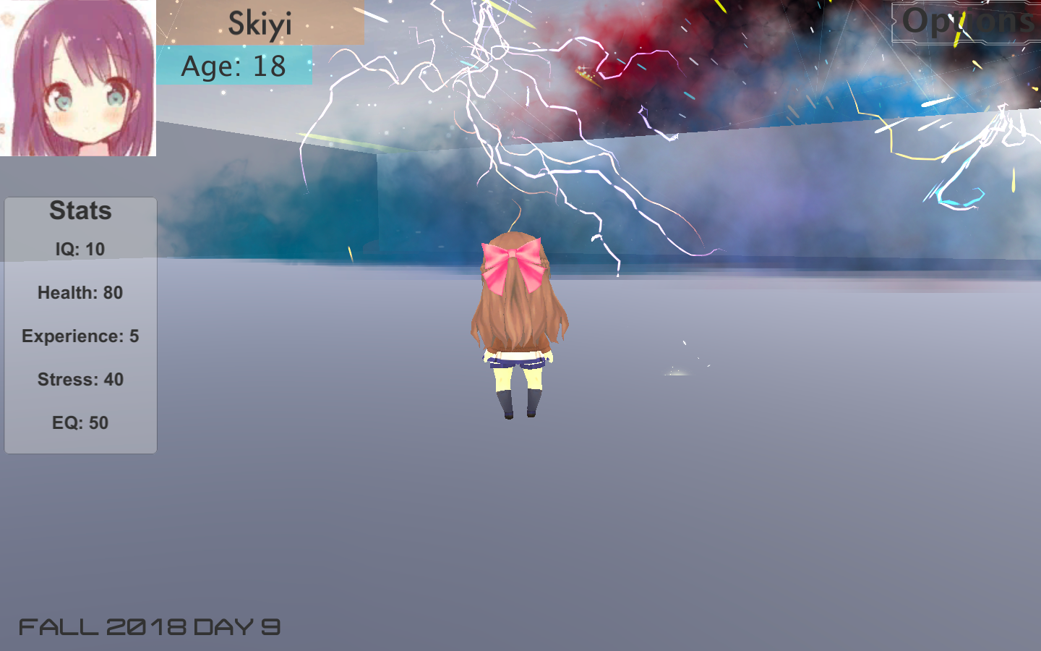

The main platform. The stats for the character are listed, if any of the stats becomes too high or too low, some event would trigger and player may lose.

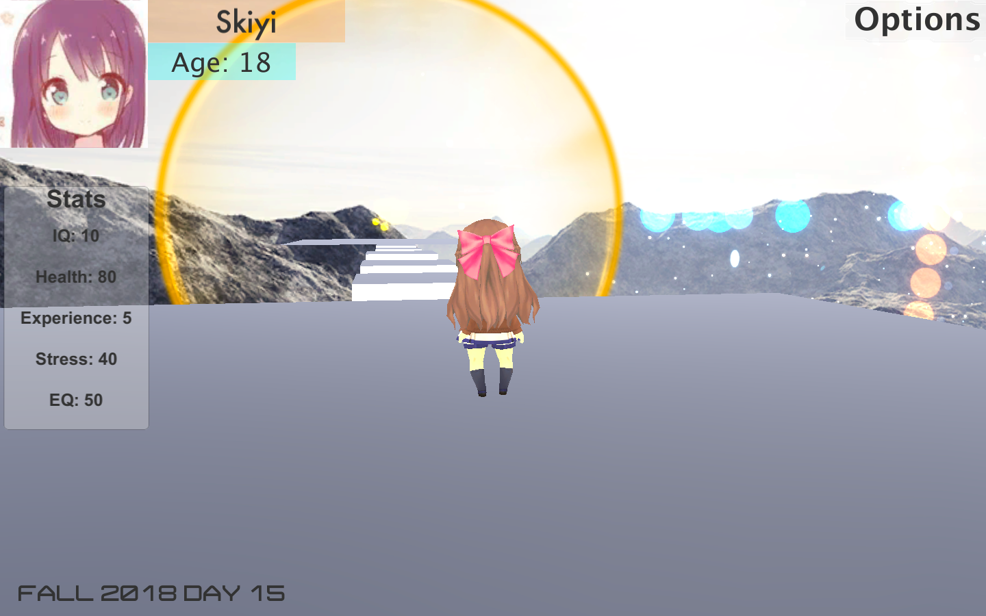

There are different events at some particular day. This event requires player to do some parkour, and rewards will be given when player reaches the destination.

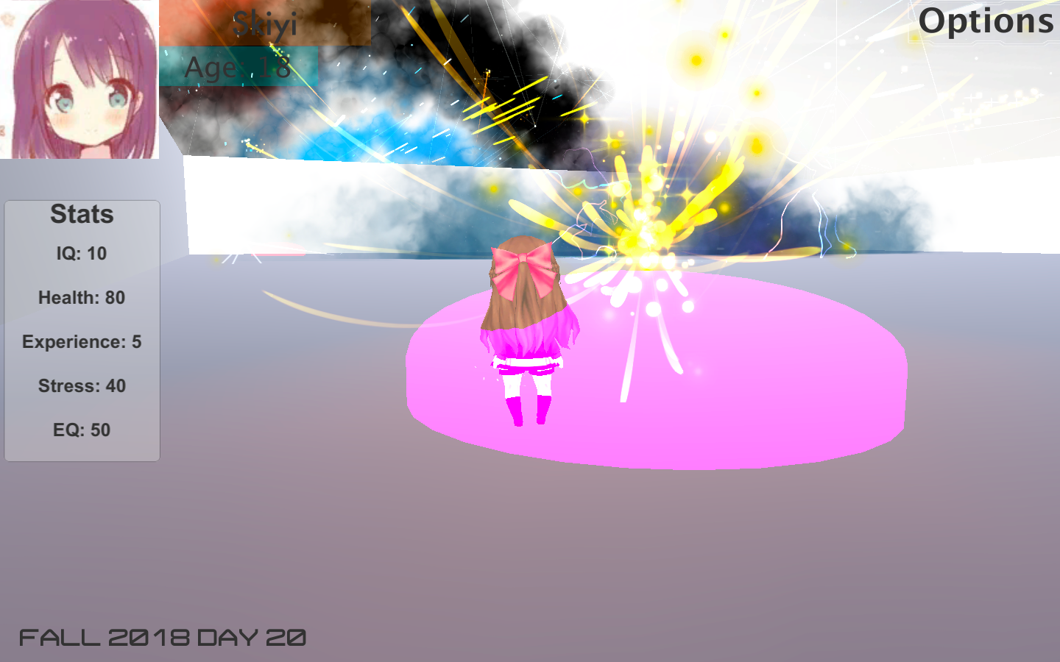

When player stays in some certain areas, the stats will change. Some stats will increase and some will decrease. Player can view the functionality of each area in options-hints.

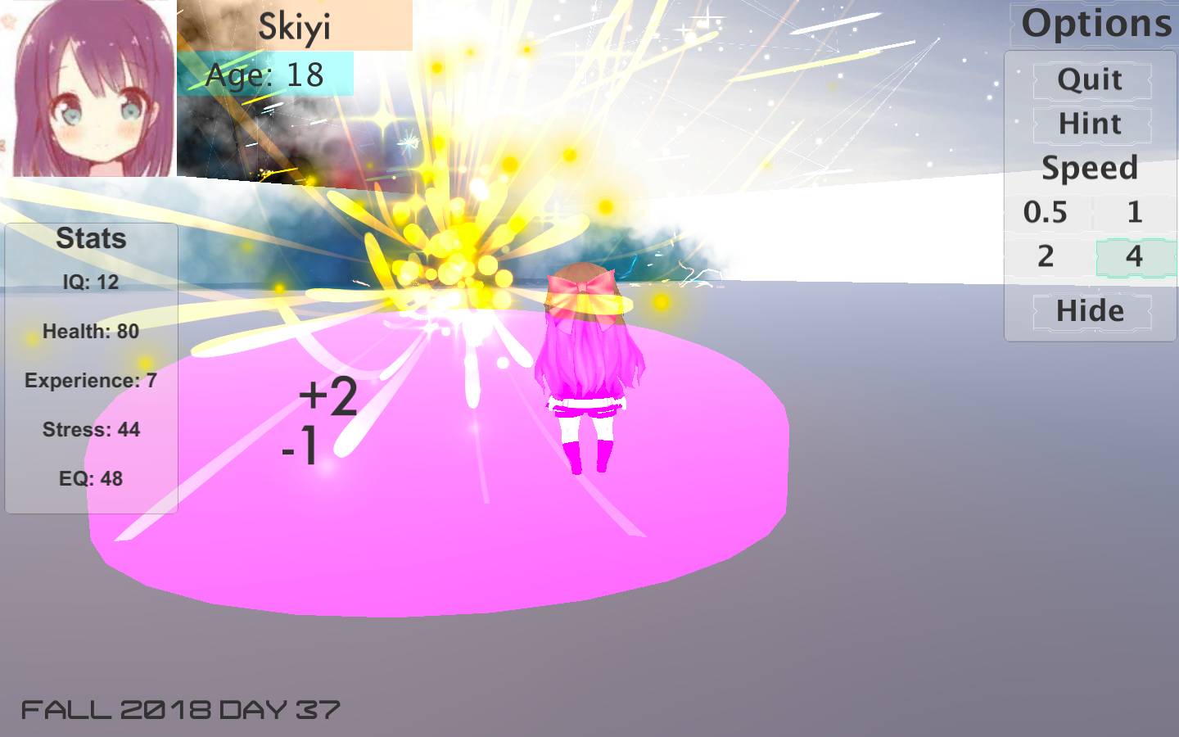

Player can modify the game speed in the options.

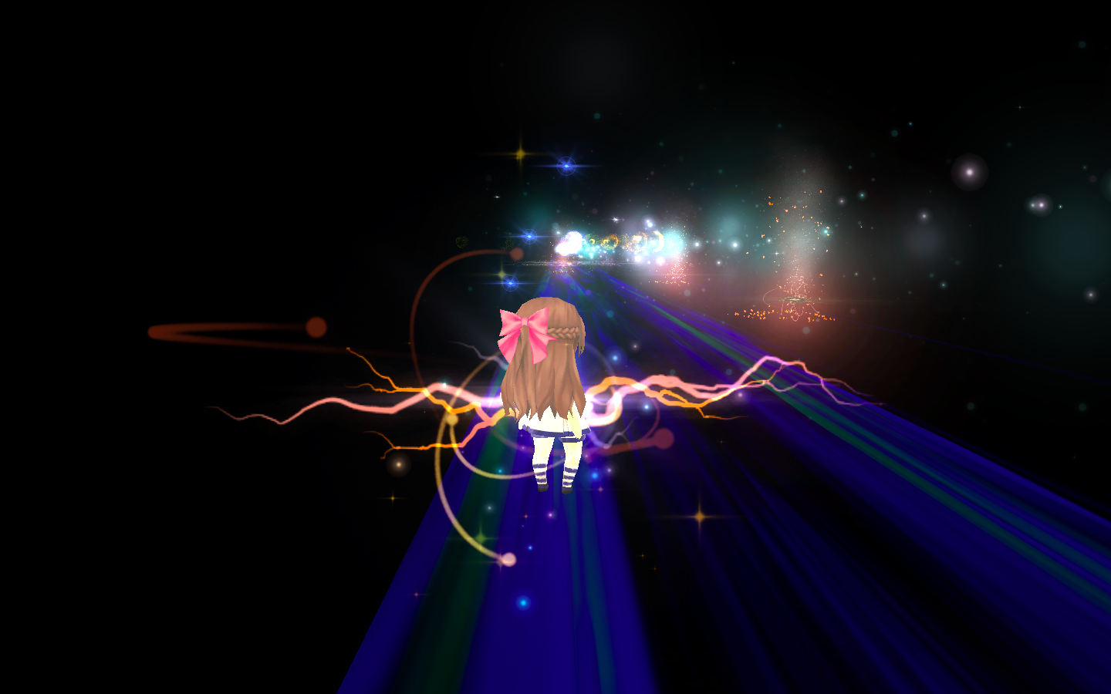

The second event. Player runs to the destination, avoiding fires.

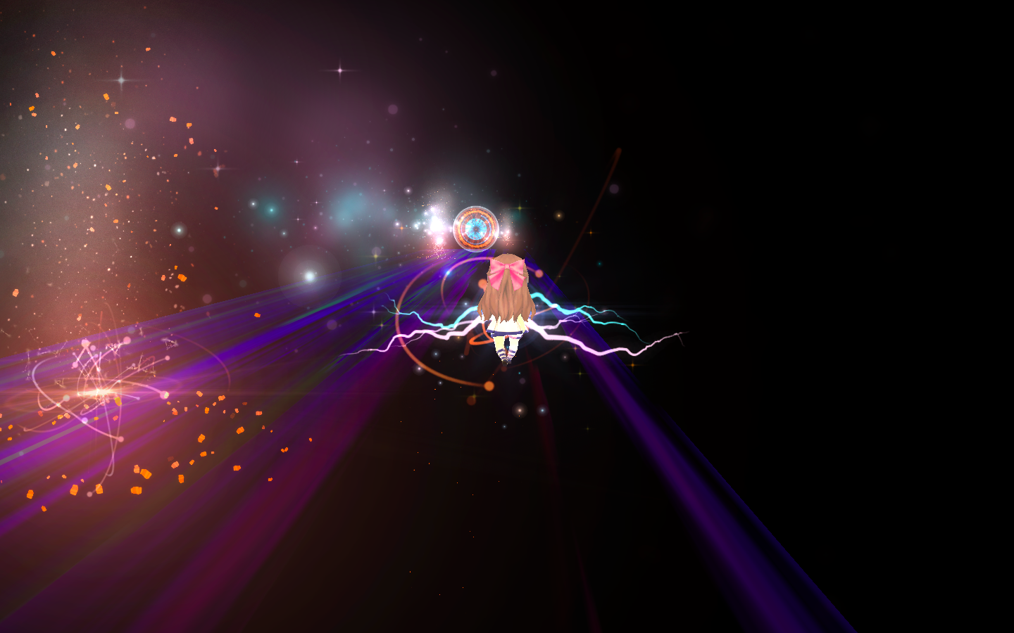

Destination is ahead!

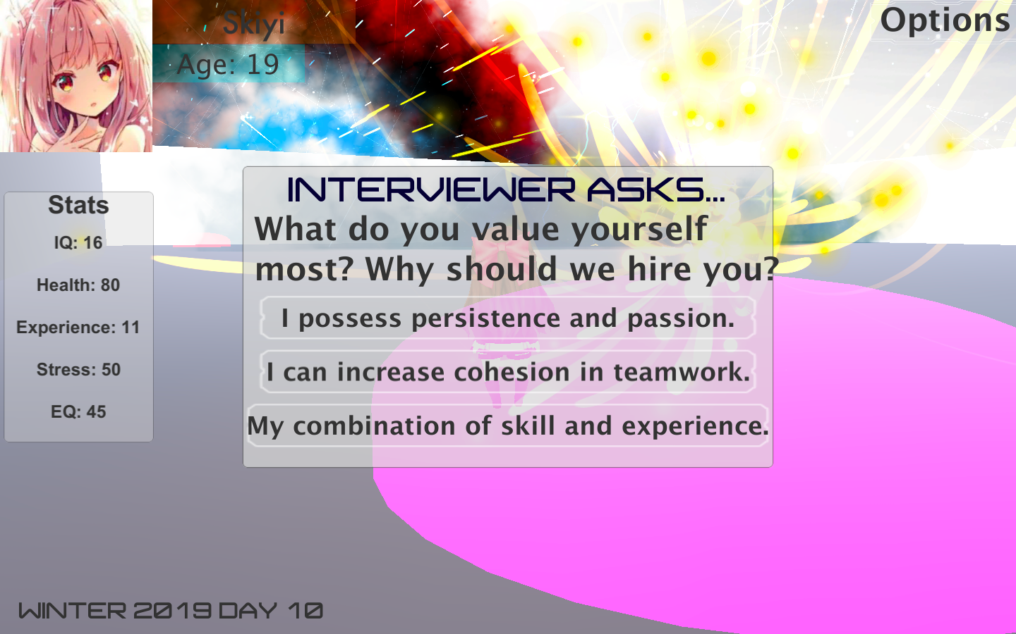

More events that require interaction.

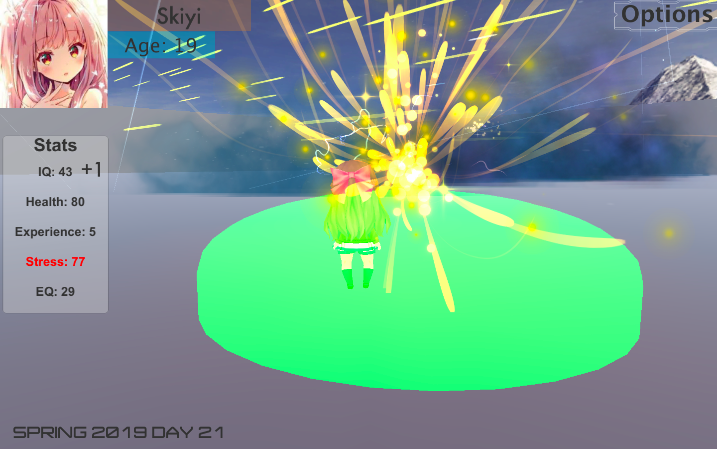

When some stats get too high or too low, it turns red as a warning. Something bad will happen if it reaches a limit!

This is a life simulation game that simulates the college life of a programmer. As this is a project created at SD Hacks, some UCSD elements are included.

To play the game, the player needs W/A/S/D to move around, space to jump. Player can modify the game speed, view the hints or quit a game in the options menu. Player needs to stay in certain areas to change the stats.

The game simulates the everyday experience and common events that a programmer usually faces in college. The stats and events are designed to help intended programmers to get a pre-understanding of how CS college life is like. Too much study will result in low EQ and high stress, while too much fun or socializing will result in the failing of courses.

The hardest part is modifying the change of stats and designing events. I tried to make the events fun and challenging, so it would not be easy to get the high rewards; also, players can challenge these events again after one year in game. Setting up the game platform and particle system is also challenging, as the ground looks pretty monotonous without the particle system.

In the future, I plan to set up more branches, create more events and set an ending. Also, I plan to upgrade the platform so it would be more interesting to walk and stay at certain areas.

The project can be viewed at <https://devpost.com/software/college-life-of-a-programmer>.

**Game: Super Mario 3D**

Screenshots

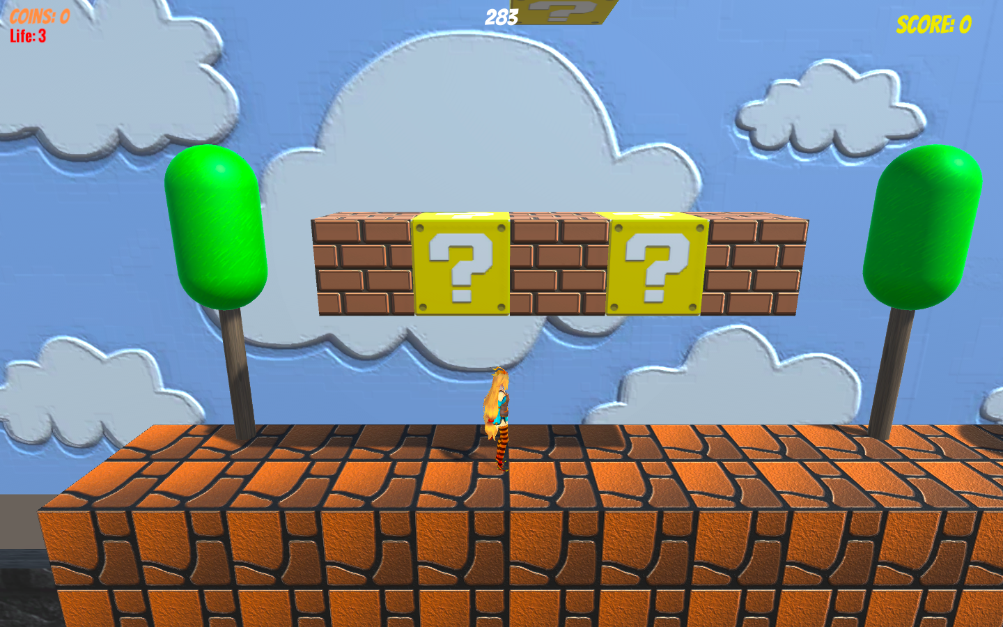

World 1-1. The question mark contains mushroom that makes the body bigger.

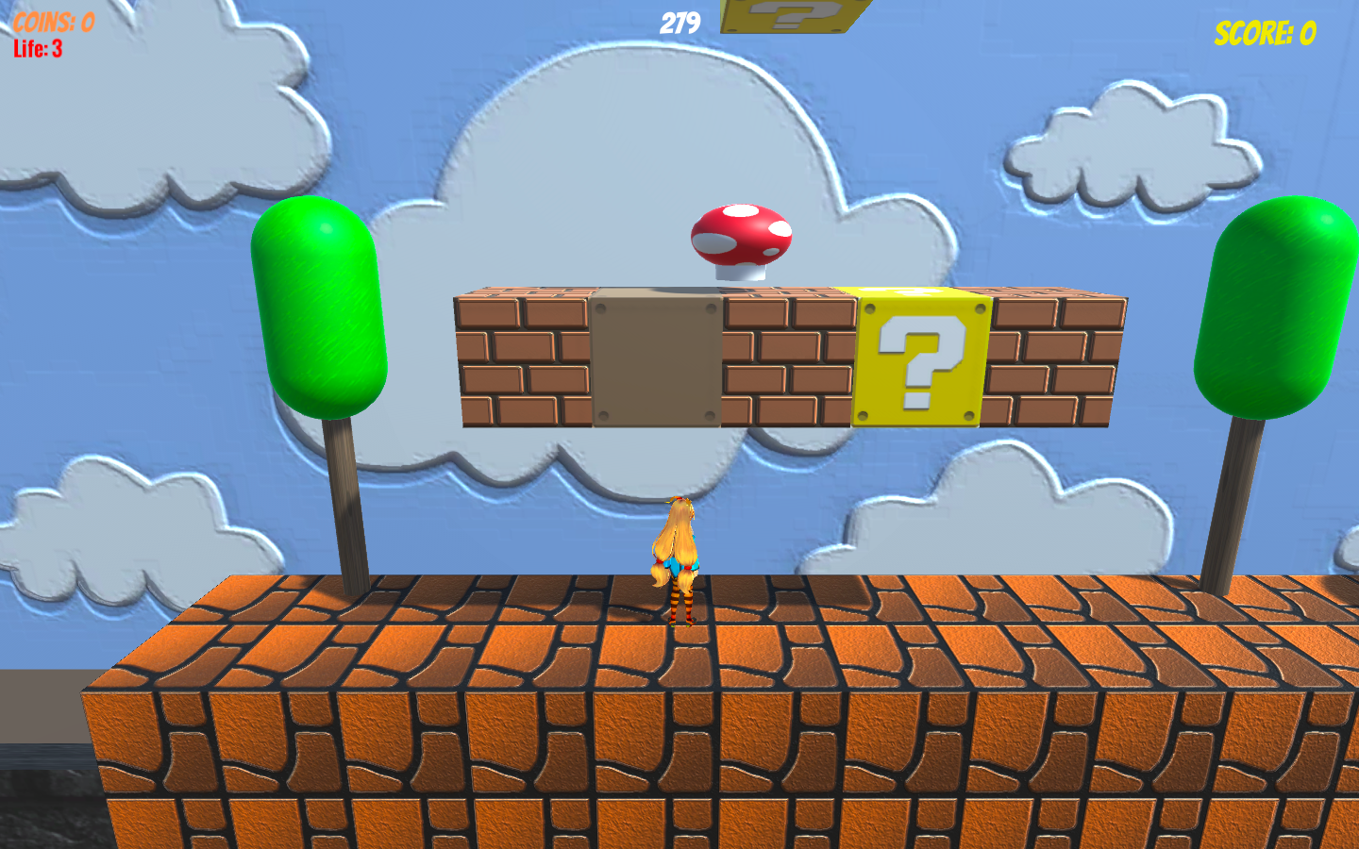

When bumped, the mushroom will get out and the question mark block is disabled.

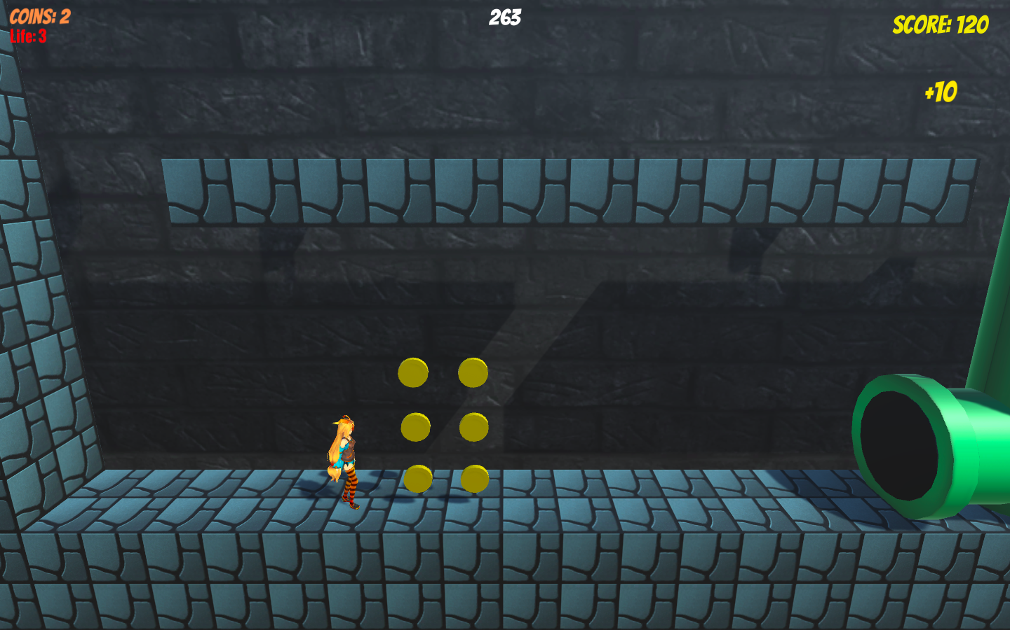

Player can go to the underworld through the pipe and collect coins.

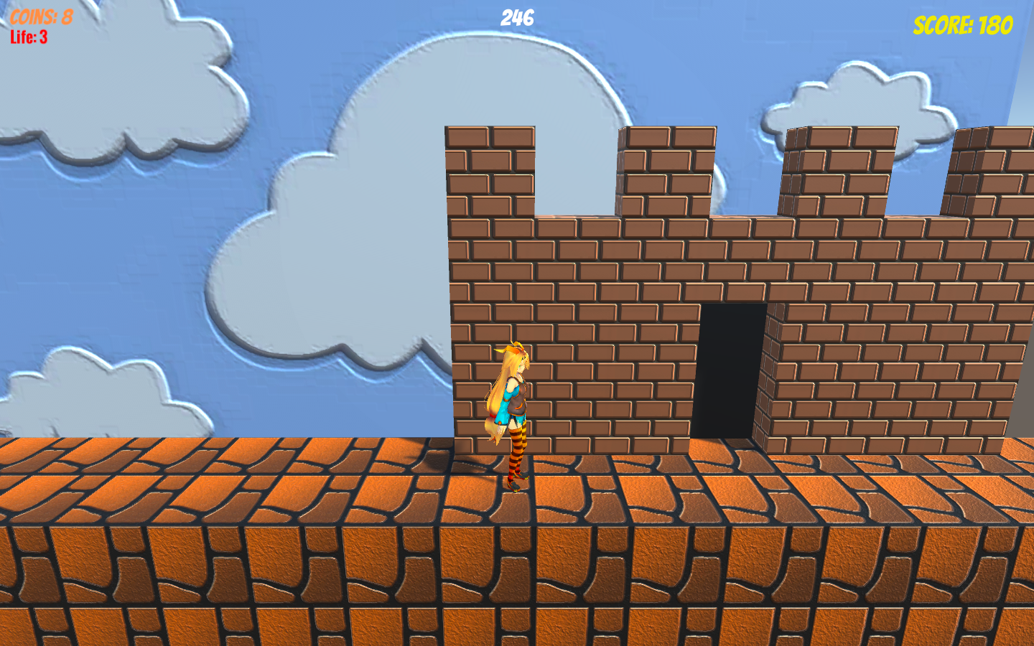

Reach the castle to pass each level.

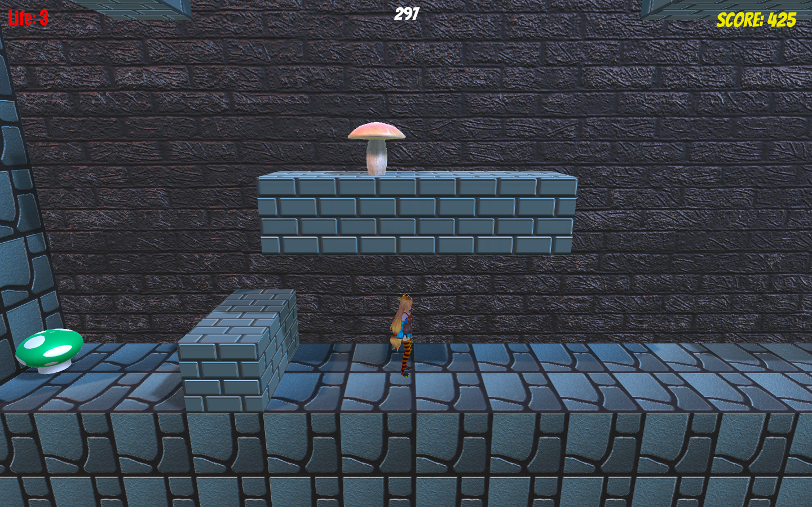

World 1-2. The mushroom on the top is an enemy, the green mushroom can increase the number of remaining lives by 1.

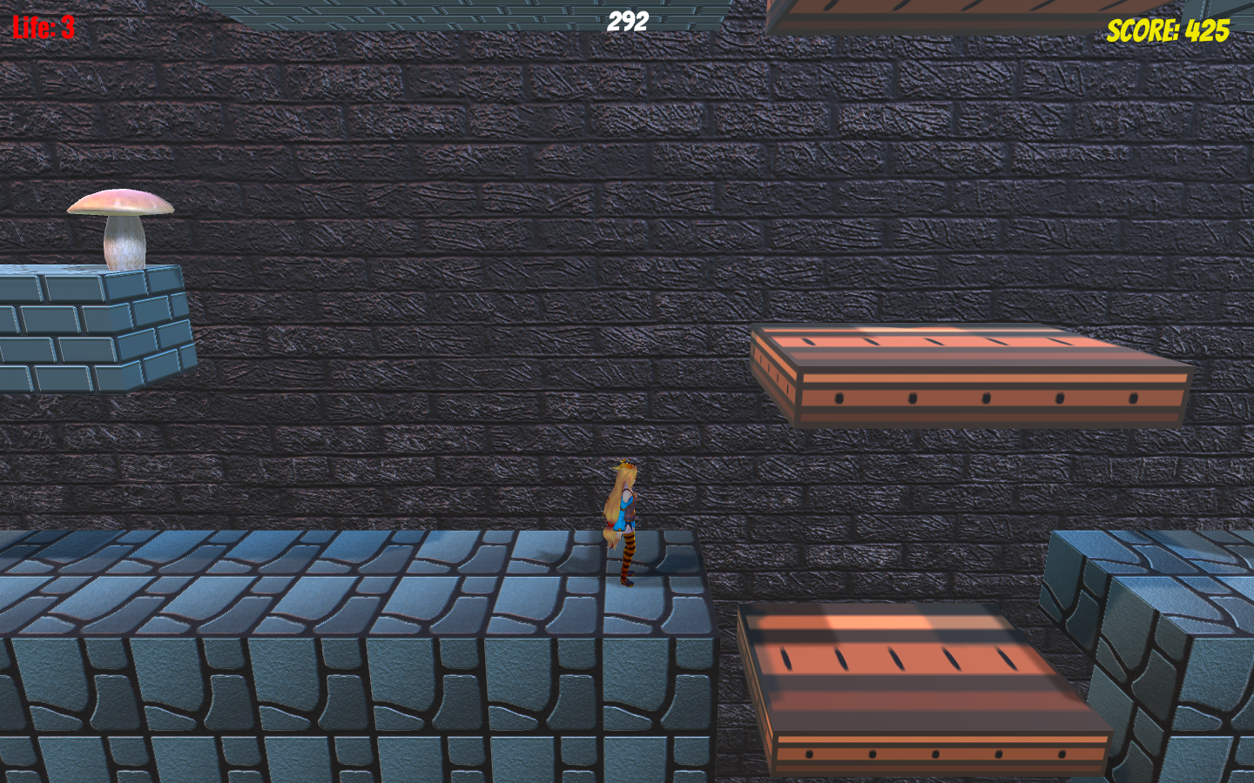

Moving platforms. Go through the platforms to the other side.

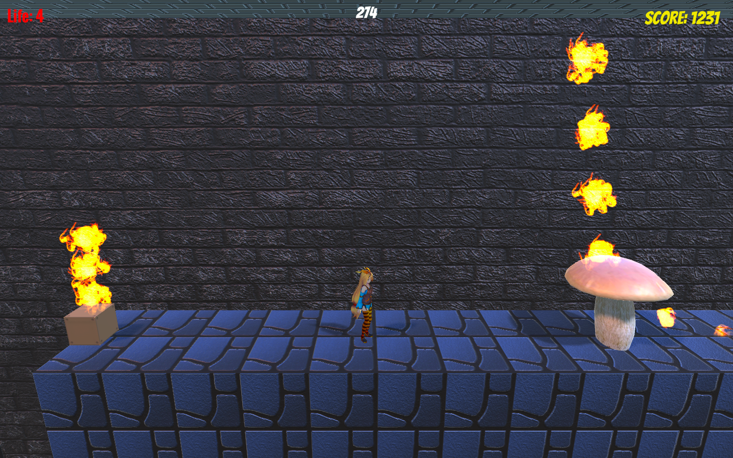

Boss of world 1-2. Avoid the fire surrounding it and jump on its head to eliminate the enemy!

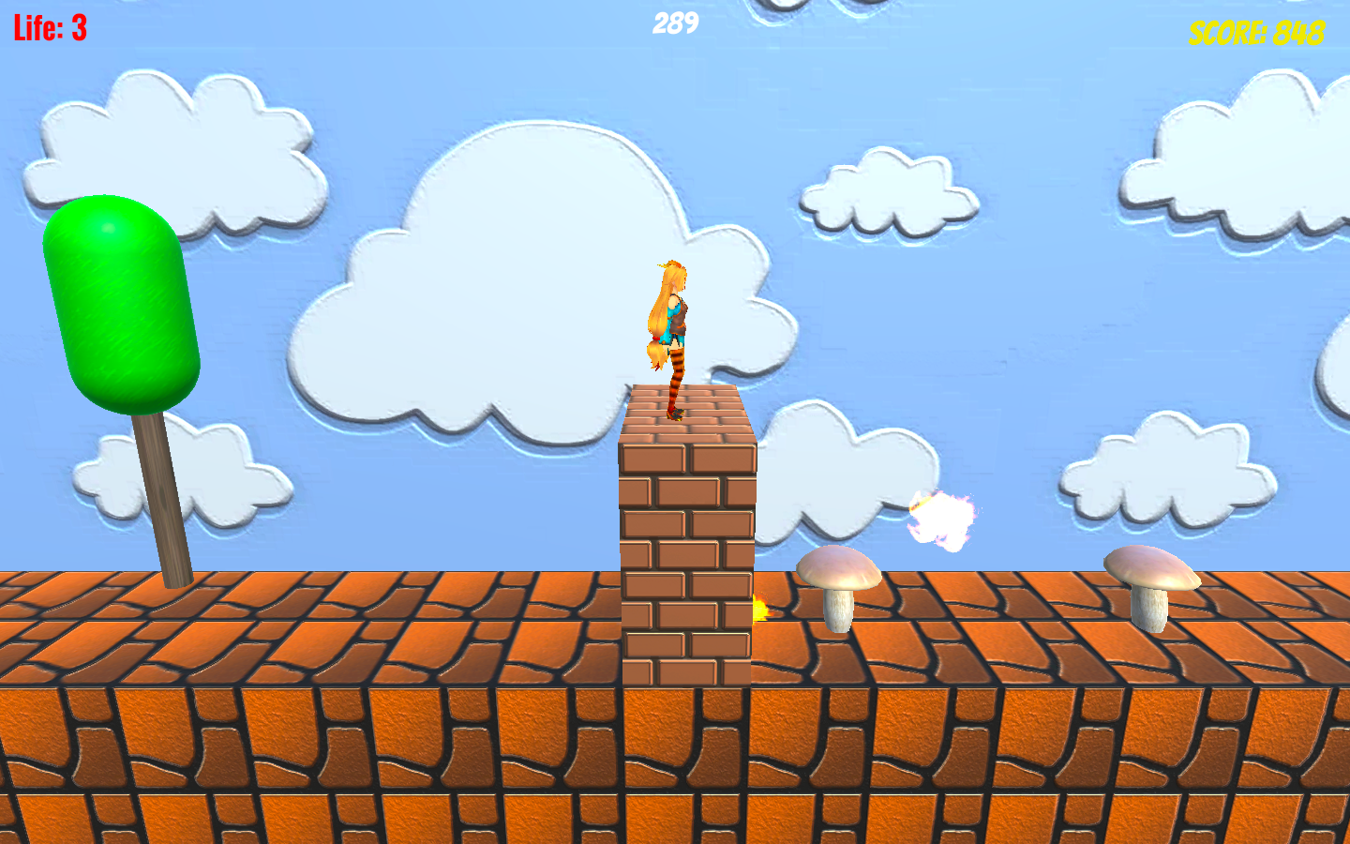

World 2-1. The small mushroom also has fire surrounding it, so try to avoid it.

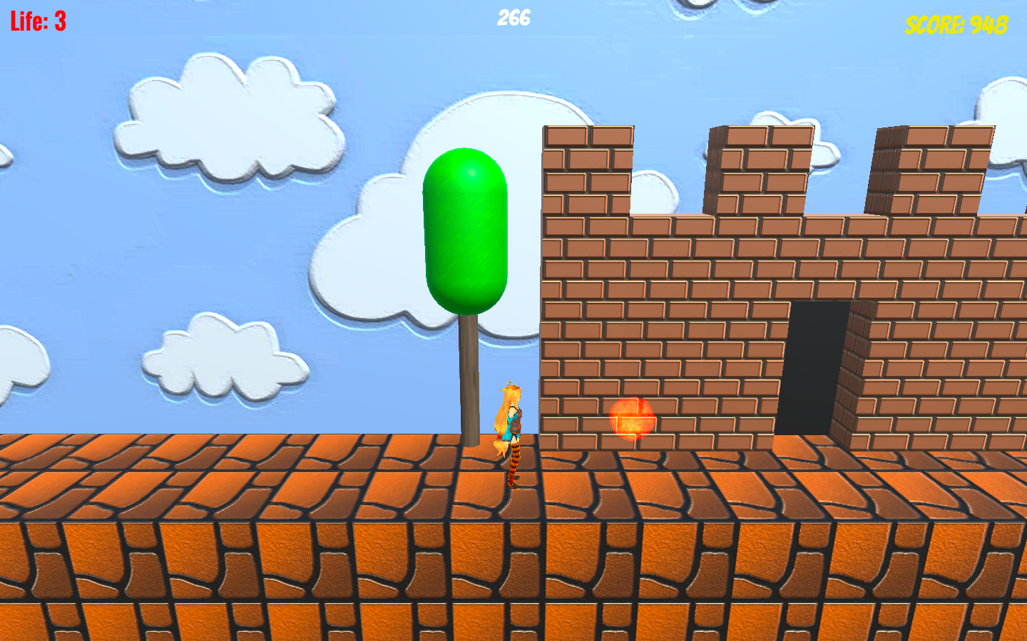

That is a trap! Fire bullets will target at the character at certain point, so be careful.

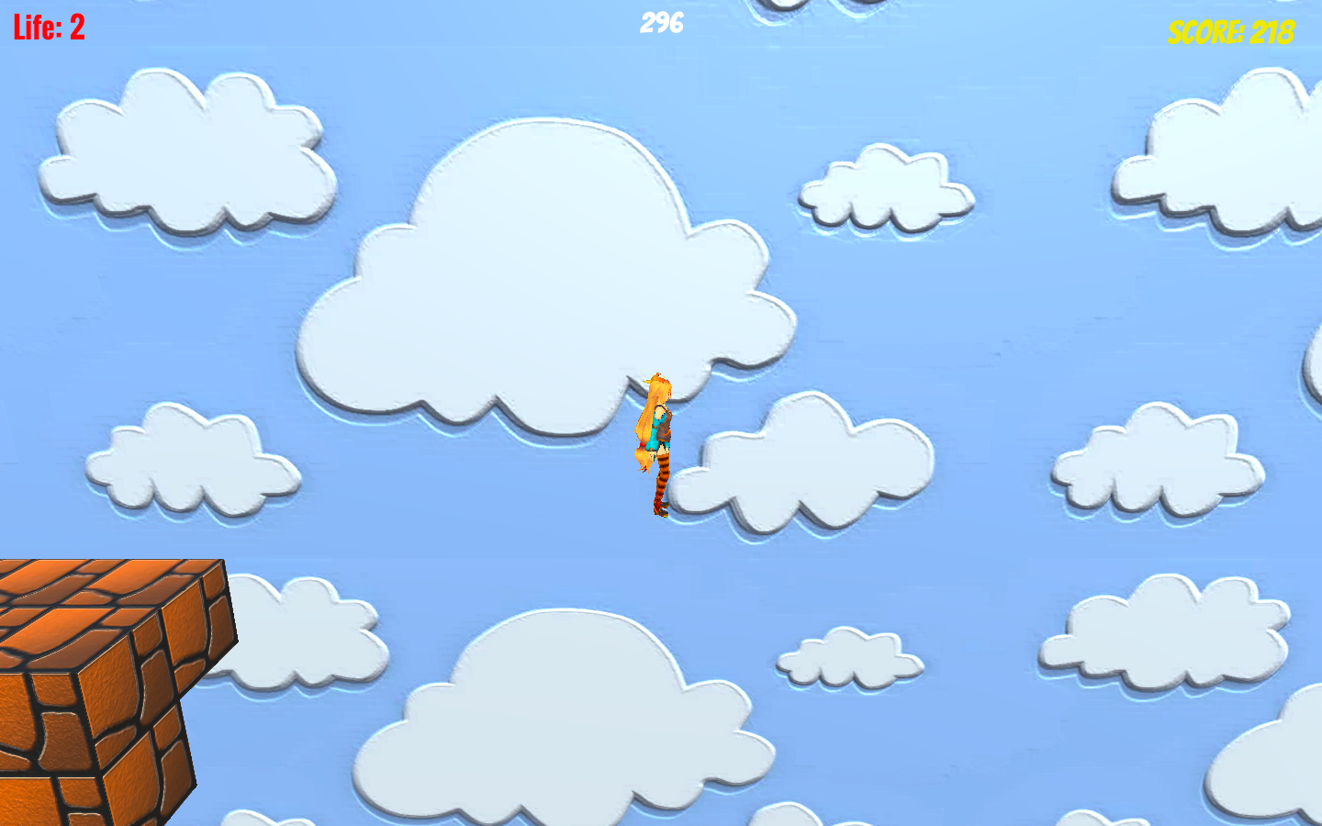

World 2-2-1. Try to find the invisible blocks!

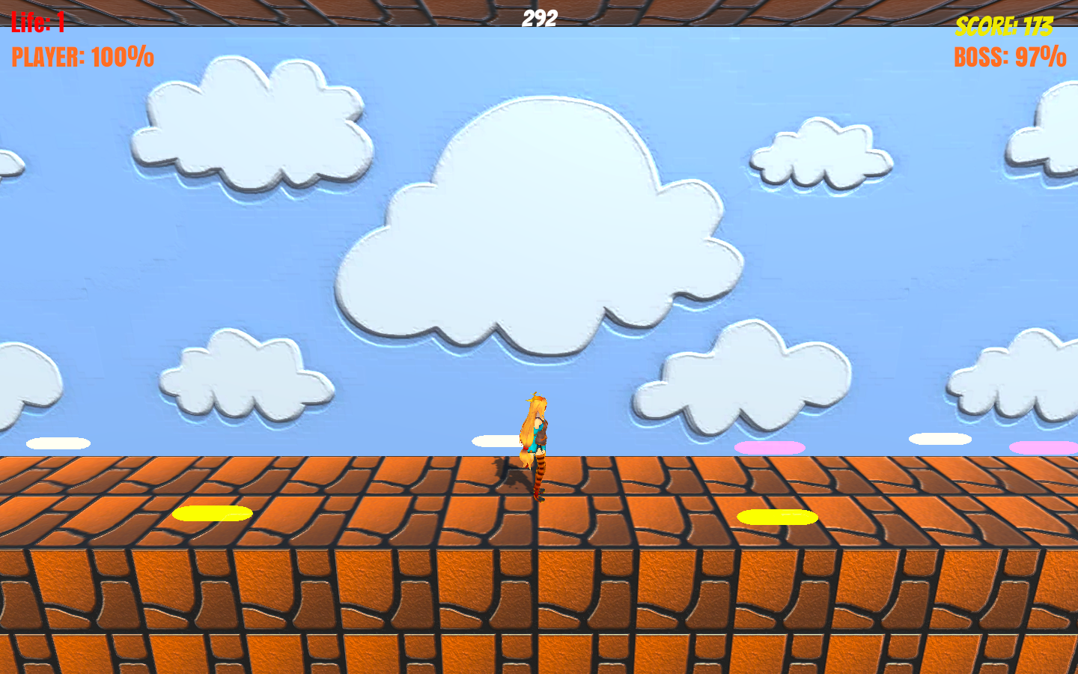

World 2-2-2, the final boss battle. Use your own barrage and avoid enemy barrage to win.

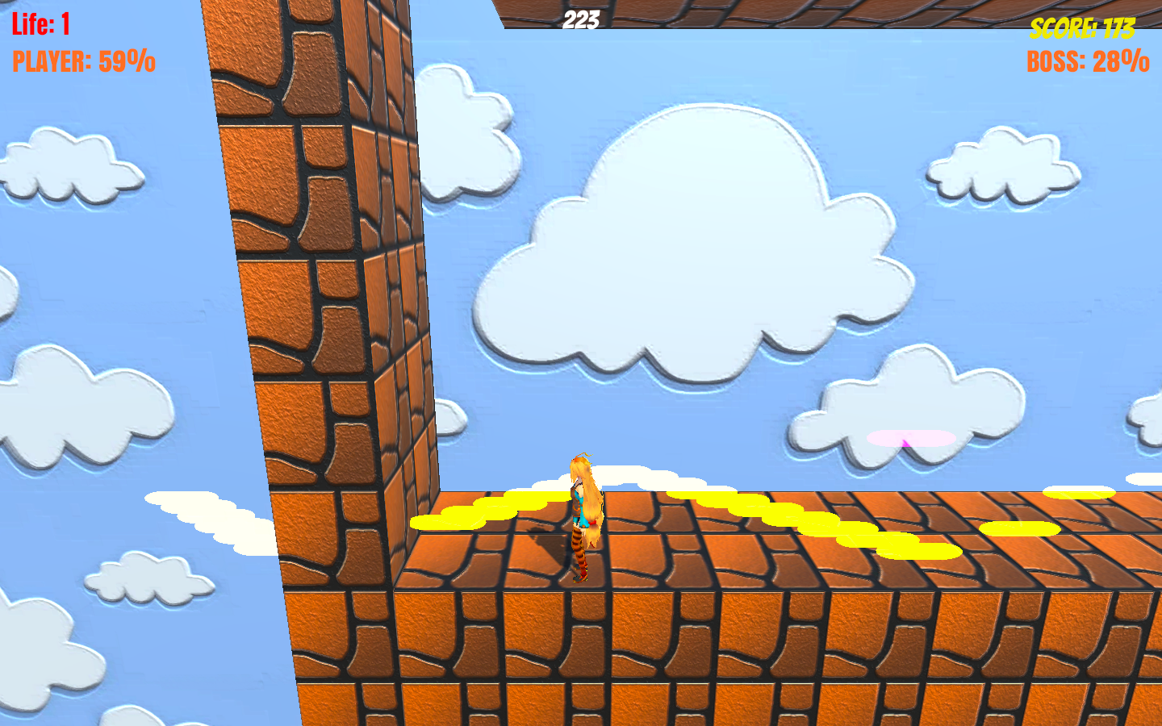

There are three stages, and a series of bullets will be fired between these stages.

This is a 3D adventure game that extends the classic Super Mario game.

To play the game, the player needs W/A/S/D to move around, space to jump. Player needs to avoid enemy bullets and contact with enemies. Player can step on the enemies to eliminate them.

The game credits to tutorial and materials from Jimmy Vegas, with more elements created on my own. I added more levels and more elements, such as traps and the final barrage battle.

This is my first project in Unity, so getting accustomed to everything is a challenging part. The gradually increasing difficulty between levels is also very challenging to design.

In the future, I plan to make more levels, add more levels, increase the game platform and UI and make the final boss battle more challenging and skill-required.

**Game: Video Games: Helper or Killer?**

Screenshots



Self-introduction. The story tells about a girl struggling with sense of loneness and follows her friend’s advice to play video games.

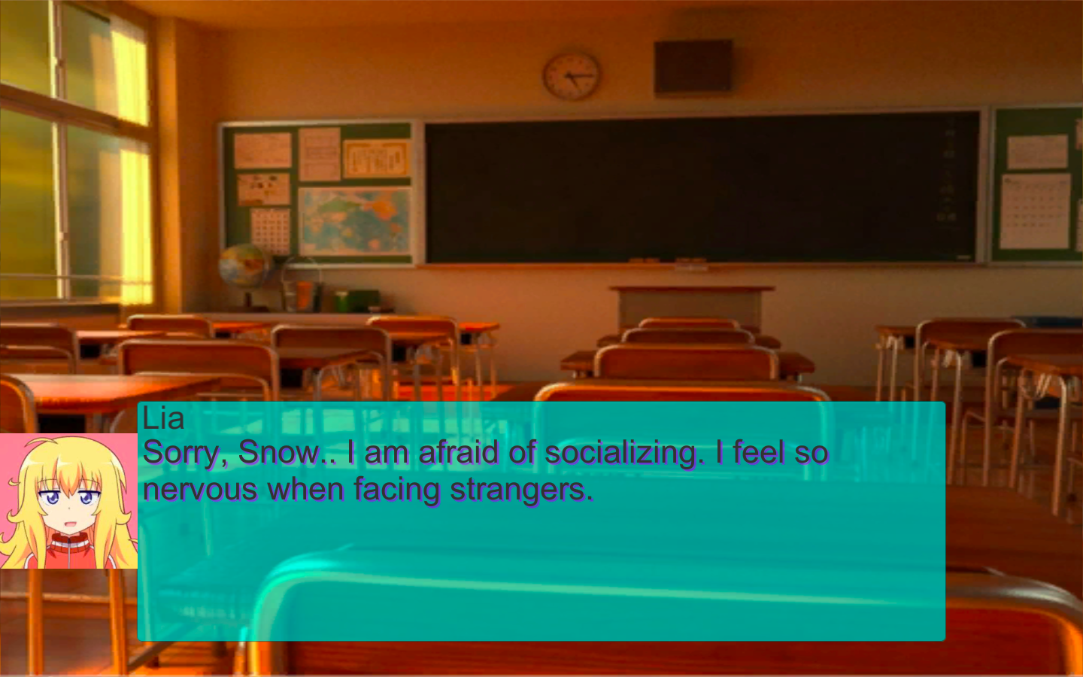

Conversation in a classroom. The heroine is asking for help.

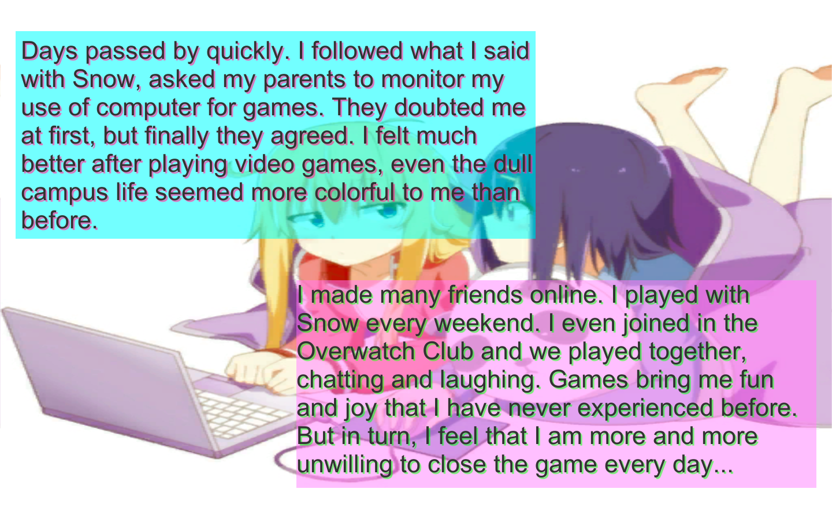

Pros and cons of video games.

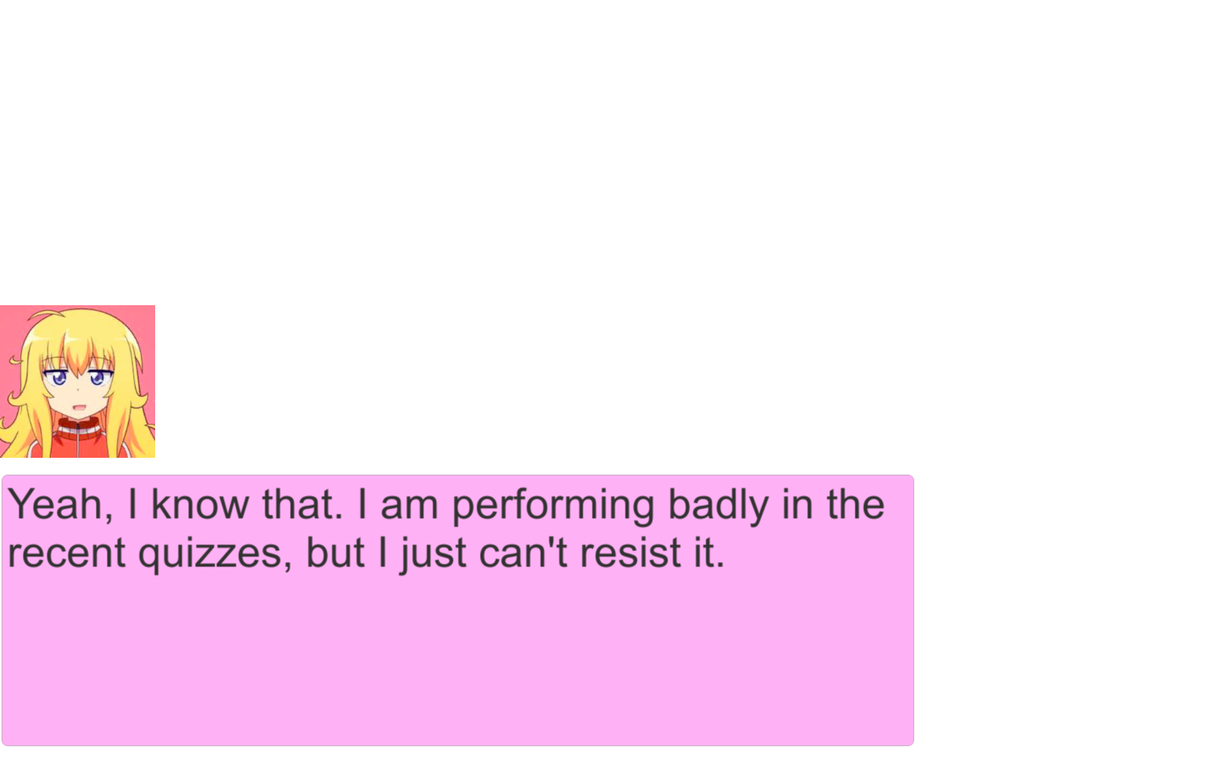

A common problem that a video game lover may encounter: the games are so attractive!

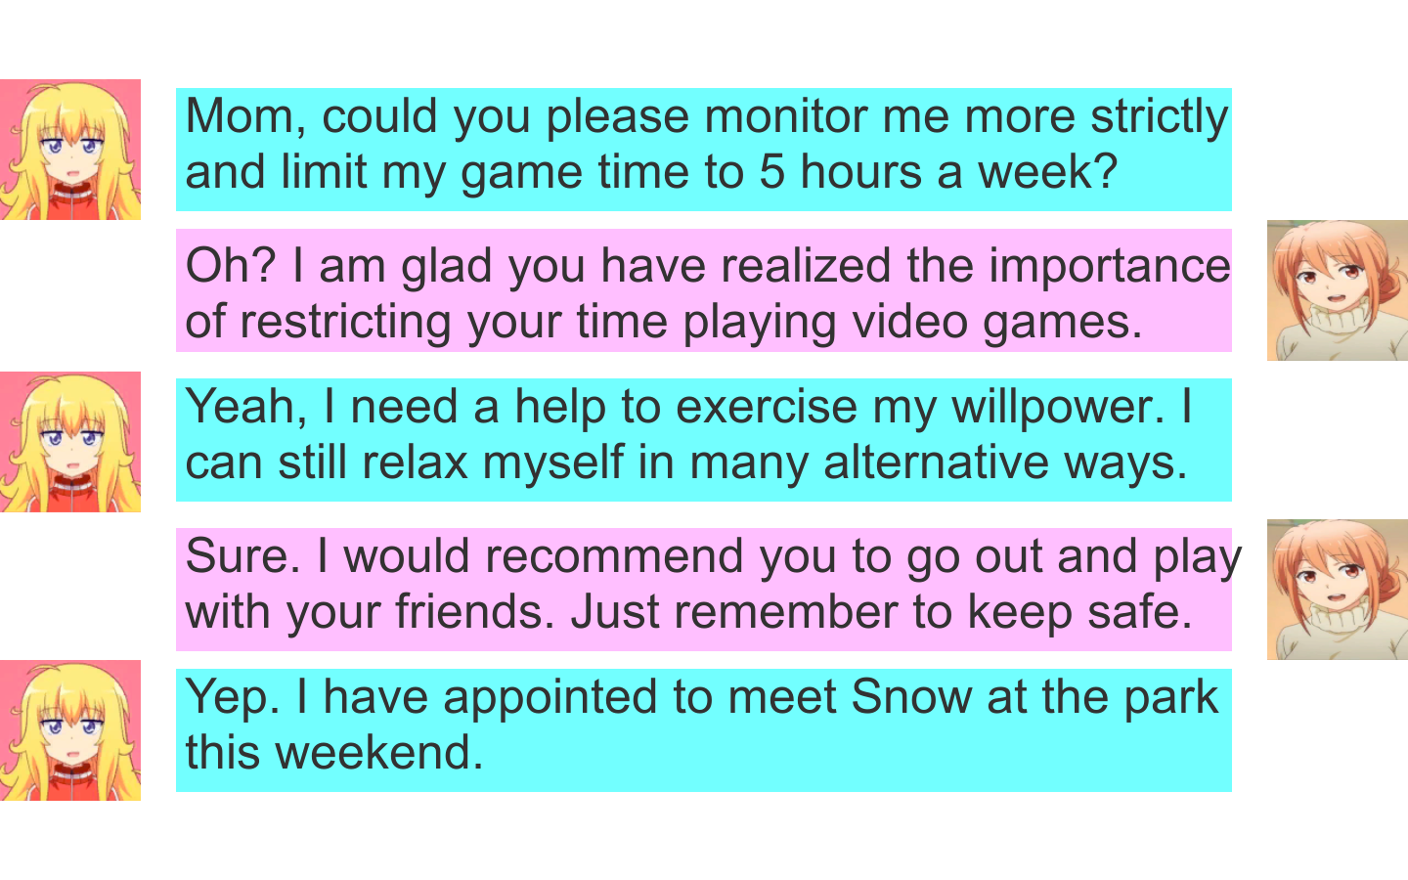

More conversation between heroine and her mom on restricting playing video games and alternative ways of destressing.

This game was made for the multimedia final project for the college writing course. It is made completely with UI, filled with conversations and monologues.

To play the game, the player only needs to press the continue button shown at certain scenes as there is no branches.

The game tells about the story of a girl at high school, who finds herself bored at everyday study life. She goes to her best friend for help, who recommends her making friends through video games. Though video games are indeed interesting and she does make some friends, she is struggling with the balance of study and game as she gets addicted to video games. Moreover, bad sides of video games, such as rumoring, also make her dismayed. Finally, she asks for her mother’s monitoring, plays with friends outside and dive into something deeper than games to make video games actually a helper.

The hardest part is setting all the UI and animations. To make the words more like a conversation, I set the words to appear one by one. Also, it is hard work to make the game UI pretty and concise.

In the future, I plan to set up some branches for players to choose instead of a single branch, and turn this into an educational novel game.